Tech Assurance Group Review Template

Revision History:
No. | Version | Date of Publishing | Author | Reviewer | Approver
1 | 1 | 6th March 2026 | EA Team | Vikas Baweja, Gopal Chaubey, Sagar Gulati, Rajesh Lad, Manoj Gupta, Biswajit Baruah, Kallol Sarkar

Tech Assurance Group Reviews (To be proportionately filled)
This is the single TAG submission template. All projects start with the Impact Assessment form. Based on the assessment outcome, the system classifies the request into NR (No Review), LR (Light Review), or FR (Full Review). Only the sections marked applicable for the assigned category must be completed.

1.Basic Details (applicable to all categories)
Project Name
Business Unit
Sub-BU / Location
Functional Owner
BU IT Owner | Kiran KR
Application/Project Type | AI (Digital project)
High-level Objective

2. Standardization & Reuse Assessment (NR / LR / FR)
Mandatory section enforcing the group standardization mandate.
Capability | No
Similar solution existing in the Group. (provide reference to an existing solution or prior TAG/ARB ID) | No
Below section needs to be updated if answer to above question is Yes
Overlap Estimate
(Significant / Moderate / No overlap)
Seeking Exception? (Yes/No)
Exit / Convergence Strategy (in case of exception)
Delta scope that needs to be reviewed (In case of reuse)

3. Business Requirements (NR/LR/FR)
Add approved Business requirements to this table or attach approved BRD
# | High Level Business Requirements | Must Have / Nice to Have
1 |  | Must-Have
2 |  | Must-Have
3 |  | Must-Have
4 |  | Must-Have
5 |  | Must-Have
6 |  | Nice-to-Have
7 |  | Nice-to-Have
8 |  | Must-Have
9 |  | Must-Have
10 |  | Must-Have
11 |  | Must-Have
12 |  | Must-Have
13 |  | Must-Have
14 |  | Must-Have
15 |  | Must-Have
16 |  | Must-Have

Attach or embed process flow diagram if available.
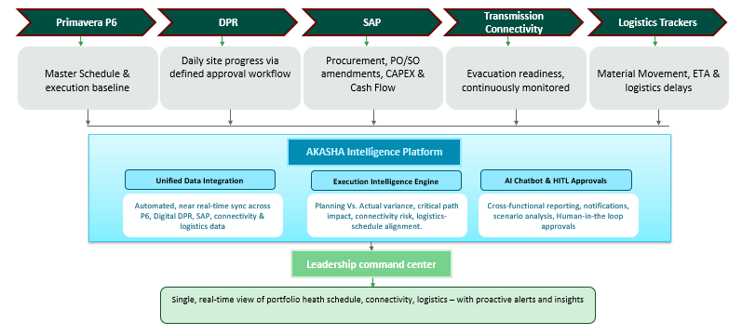

4. Vendor Details (NR/LR/FR)

4.a No Review
4. b Light Review
4.c Update details pertaining to vendor in below section
# | Evaluation Criteria | <<Vendor 1>> | <<Vendor 2>> | <<Vendor 3>>
1 | Company size (latest revenue & headcount) | 142 FTE
2 | Size of Customer Base (Global and India) along with names of top customers (at present) | 12 active Customers Globally (Top Customers: KLA Tencor, CMA CGM, Petrofac) |  6 Active Indian Customers ( Ujjivan Small Finance Bank, SHV Energy)
3 | Presence in Adani Group (mention BU/Projects) | Adani Green Energy, Adani Total Gas Limited, Adani Energy Solutions Limited, Adani Electricity Mumbai Limited)
4 | Functional ranking
5 | Rationale behind Functional ranking
6 | Technical Ranking
7 | Rationale behind Tech ranking
8 | Overall Ranking
9 | Additional remarks on overall ranking

5.Solution Overview & Architecture Snapshot (LR / FR)
Deployment Model (SaaS / Adani Cloud/ On Prem) | Adani cloud
Core functional components/modules | Master Schedule & execution baseline, Daily site progress via defined approval workflow,  Procurement, PO/SO amendments, CAPEX & Cash Flow, Evacuation readiness, continuously monitored, Material Movement, ETA & logistics delays
User Type (Internal/External) | Internal
Who will be the users? | CXOs, PMAG team, Techno commercial team, Projects team (Wind, Solar)
Internet Facing (Yes/No) | No (accessible only in Adani network)
Attach or embed a one-page logical architecture diagram.
Logical Architecture – Akasha Intelligence Platform:
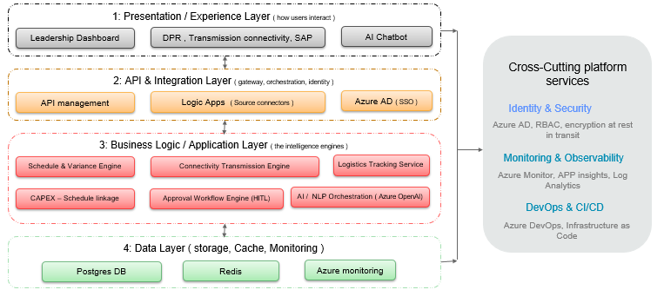

6. Technology Stack (LR / FR)
List key technologies used. Mark deviations from group standards explicitly (Standard vs Exception).
Layer/Technology components | Technology / Product | Version | Standard / Exception | Underlying Compute (where is this deployed?)
Frontend | React 18 + Vite + TailwindCSS + Recharts |  |  | NGINX Ingress Controller on AKS
Backend | Python 3.11 + FastAPI + asyncpg |  |  | NGINX Ingress Controller on AKS
Database | Azure PostgreSQL Flexible Server (Managed) – , | General Purpose, 4 vCores |  | 128 GB. SSL enforced. Auto-backup 7 days.
Analytics | E charts
Others - | AI: Azure OpenAI GPT-4.1
Job Scheduler: Windows Task Scheduler
Monitoring: Azure Monitor + Container Insights + Log
Version Control: GitLab (Source Code + CI/CD)

7. Integration Interface Register (LR / FR)
From System | To System | Purpose | Integration Method | Middleware/ Orchestration Service | Authentication Method | Data being exchanged | Mode & Frequency
Oracle Primavera P6 | Akasha platform | Project planning, scheduling, milestone tracking, and progress monitoring. | REST API | Point-to-Point | Basic Authentication / OAuth (as configured) | Project, Activities, WBS, Milestone, Progress Updates | Real-time/ On-Demand
Digital DPR | Akasha platform | Daily progress reporting, approvals, and project status management. | REST API | Point-to-Point | SSO / JWT | Daily Progress, Approvals, Project Status | Real-time
Transmission Connectivity Dashboard | Akasha platform | Transmission connectivity and commissioning milestone tracking. | REST API |  | API Token | Connectivity Status, SCD, ECOD | Batch / On-Demand
SAP ERP (SharePoint) | Akasha platform | Financial, procurement, CAPEX, and project cost data integration. | Tenant ID, Client ID |  | API Token | SAP Reports, CAPEX, Procurement, Financial Data | Batch / Scheduled

8. Non-Functional Requirements (NFRs) (LR / FR)
Specify measurable targets. If unknown, provide initial assumption and validation plan.
NFR Category
Deployment Location | Azure Cloud – India region
Availability Target (%) | 99.9% application uptime target. Azure PostgreSQL SLA: 99.99% (with zone redundancy). AKS SLA: 99.95%.
RTO requirement (in minutes/hours/days) | 24 Hours
RPO requirement (in minutes/hours/days) | 4 Hours
HA Strategy | Azure-based High Availability leveraging Azure PostgreSQL Flexible Server with Zone Redundancy and application deployment on Azure Kubernetes Service (AKS).
DR Strategy | Recovery through Azure-managed infrastructure with RTO of 24 hours and RPO of 4 hours.
Backup Strategy | Expected to leverage Azure PostgreSQL managed backup capabilities.
Sizing & Scalability | Solution deployed on AKS with cloud-native scalability support. Scale-out capability available through Kubernetes cluster scaling.
Performance Requirements | Dashboard load time < 2 seconds; API response time < 500 ms for standard queries.
Concurrent Users / Transactions per Sec | 20 users/sec

9. Key Risk & Deviation Summary (LR / FR)
Area | Risk / Exposure | Mitigation / Control
Data Integration | API limitations, integration failures, or data inconsistencies across Primavera P6, Digital DPR, SAP, Module Tracker, and other source systems may impact data synchronization and reporting accuracy. | Conduct early integration testing, implement validation rules, API monitoring, exception handling, and data reconciliation processes.
User Adoption | Resistance from users transitioning from Excel-based and manual reporting processes may result in low platform adoption and continued use of offline trackers. | Conduct user training, provide intuitive role-based dashboards, establish leadership sponsorship, and execute a structured change management program.
Data Quality | Inaccurate, incomplete, duplicate, or delayed source data may lead to unreliable dashboards, reports, and decision-making. | Define data ownership, implement automated validation checks, establish data quality monitoring, and maintain audit trails.
Approval & Workflow Management | Delays in Human-in-the-Loop (HITL) approvals and validations may impact project execution timelines and decision-making. | Define approval SLAs, configure automated reminders and escalation workflows, and provide approval status tracking dashboards.
Performance & Scalability | Slow dashboard loading, chatbot response delays, or performance degradation with increasing project volume may reduce user confidence. | Implement scalable cloud architecture, conduct performance and load testing, enable system monitoring, and optimize application performance continuously.
Security & Compliance | Unauthorized access, data leakage, or non-compliance with organizational security policies may expose sensitive projects and financial data. | Enforce RBAC, SSO, encryption at rest and in transit, audit logging, periodic access reviews, and security compliance controls.

10. Cost & Commercial View (TCO) (FR mandatory, LR optional)
High-level TCO for transparency. Detailed procurement artifacts are not required in this template. (3-year TCO to be shared)
Cost Component | Nature of expense (One time/Recurring) | Value | Notes
Software License/Subscription
Infra & Services Cost
Annual Maintenance Cost

11. Full Review – Deep Dive (FR only)
Required only for Full Review items:
- Detailed architecture diagrams (deeper than one-page snapshot)
- Capacity and scalability analysis
- Threat model (lite or full, as per Cyber guidance)
- Operational readiness (monitoring, DR, runbooks)
- Alternatives considered / option trade-offs
- Exception rationale + convergence plan (if applicable)

12. Tech Assurance Group Decision (NR / LR / FR)
Decision (Approved/ Rejected/ Approved with Condition)
Key Recommendations
Architecture Decision

